Multiple Non-Linear Regression Analysis: Salary Data
Cailey
2026-04-26

Loading Data and Libraries
library(corrplot)
df <- read.csv("C:/Users/Cailey/OneDrive - University of South Florida/USF/Spring 26/Stats 2/Regressions/Multiple Linear Regression/Data/Salary.csv")
head(df)
## Salary Employment..in.years. Experience..in.years. Education..in.years.
## 1 57310 10 2 16
## 2 57380 5 6 16
## 3 54135 3 1 12
## 4 56985 6 5 14
## 5 58715 8 8 16
## 6 60620 20 0 12

1. Correlation Matrix
correlation <- cor(df)
print(round(correlation, 3))
## Salary Employment..in.years. Experience..in.years.
## Salary 1.000 0.824 0.189
## Employment..in.years. 0.824 1.000 -0.310
## Experience..in.years. 0.189 -0.310 1.000
## Education..in.years. 0.375 -0.108 0.645
## Education..in.years.
## Salary 0.375
## Employment..in.years. -0.108
## Experience..in.years. 0.645
## Education..in.years. 1.000
corrplot(correlation,
method = "circle",
type = "upper",
tl.col = "black",
tl.srt = 45,
title = "Correlation Matrix",
mar = c(0, 0, 1, 0))
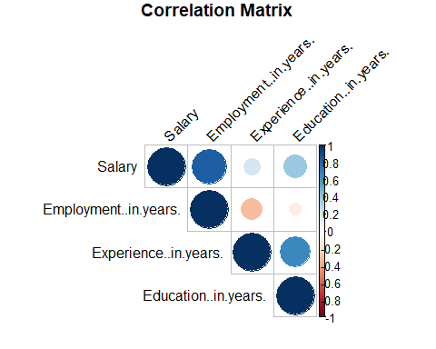

Interpretation
The correlation matrix quantifies the linear relationship between each pair of variables on a scale from -1 to +1.
- Salary & Employment (r = 0.824): Strong positive correlation — the strongest among all predictors. Employees with more years of employment tend to earn notably higher salaries.
- Salary & Education (r = 0.375): Moderate positive correlation. More years of education is associated with higher salary, though the relationship is weaker than employment tenure.
- Salary & Experience (r = 0.189): Weak positive correlation. Work experience has the weakest linear association with salary among the three predictors in this dataset.
- Experience & Education (r = 0.645): Moderate positive correlation between these two predictors, meaning individuals with more education also tend to have more work experience in this sample.
- Employment & Experience (r = -0.310): A mild negative correlation, which is somewhat unexpected but may be an artifact of the small sample size (n = 8).
- Employment & Education (r = -0.108): Essentially no linear relationship between employment tenure and education level.

2. Scatter Plots
par(mfrow = c(1, 3), mar = c(4, 4, 3, 1))
plot(df$Education..in.years., df$Salary,
main = "Salary vs. Education",
xlab = "Education (in years)",
ylab = "Salary ($)",
pch = 16, col = "steelblue")
abline(lm(Salary ~ Education..in.years., data = df), col = "red", lwd = 2)
plot(df$Experience..in.years., df$Salary,
main = "Salary vs. Experience",
xlab = "Experience (in years)",
ylab = "Salary ($)",
pch = 16, col = "steelblue")
abline(lm(Salary ~ Experience..in.years., data = df), col = "red", lwd = 2)
plot(df$Employment..in.years., df$Salary,
main = "Salary vs. Employment",
xlab = "Employment (in years)",
ylab = "Salary ($)",
pch = 16, col = "steelblue")
abline(lm(Salary ~ Employment..in.years., data = df), col = "red", lwd = 2)
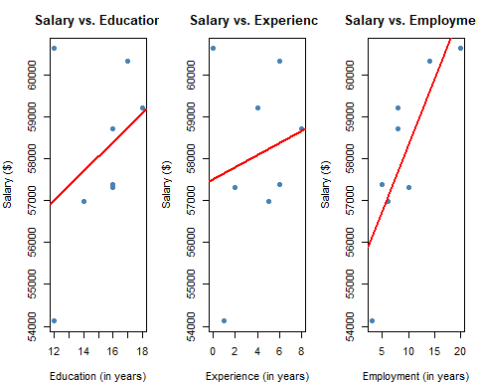
par(mfrow = c(1, 1))

Interpretation
- Salary vs. Education: Data points span education levels of 12 to 18 years. The trend line has a mild positive slope, but the scatter is wide. Notably, one individual with only 12 years of education earns over $60,000, which works against the trend. Education alone appears to be a weak predictor of salary in this sample.
- Salary vs. Experience: Experience ranges from 0 to 8 years. While the trend line is positive, the individual with 0 years of experience earns the highest salary ($60,620), which contradicts the expected direction and contributes to high variability. This suggests experience alone does not reliably predict salary here.
- Salary vs. Employment: This plot shows the clearest and most consistent upward trend. As employment tenure increases from 3 to 20 years, salary rises fairly steadily from ~$54,135 to ~$60,620. Points track closer to the trend line than in the other two plots, reinforcing that employment duration is the strongest individual predictor of salary in this dataset.

3. Polynomial (Quadratic) Regression Model
model_poly <- lm(Salary ~ poly(Employment..in.years., 2) +
poly(Experience..in.years., 2) +
poly(Education..in.years., 2),
data = df)
summary(model_poly)
##
## Call:
## lm(formula = Salary ~ poly(Employment..in.years., 2) + poly(Experience..in.years.,
## 2) + poly(Education..in.years., 2), data = df)
##
## Residuals:
## 1 2 3 4 5 6 7 8
## -66.25 -66.13 -337.71 345.15 146.47 198.71 354.54 -574.78
##
## Coefficients:
## Estimate Std. Error t value Pr(>|t|)
## (Intercept) 58083.1 308.0 188.577 0.00338 **
## poly(Employment..in.years., 2)1 5525.5 1147.0 4.817 0.13030
## poly(Employment..in.years., 2)2 1127.5 2291.6 0.492 0.70890
## poly(Experience..in.years., 2)1 2552.0 1829.8 1.395 0.39601
## poly(Experience..in.years., 2)2 -335.0 1281.4 -0.261 0.83720
## poly(Education..in.years., 2)1 1875.3 2885.0 0.650 0.63306
## poly(Education..in.years., 2)2 723.5 1386.1 0.522 0.69374
## ---
## Signif. codes: 0 '***' 0.001 '**' 0.01 '*' 0.05 '.' 0.1 ' ' 1
##
## Residual standard error: 871.2 on 1 degrees of freedom
## Multiple R-squared: 0.9755, Adjusted R-squared: 0.8285
## F-statistic: 6.635 on 6 and 1 DF, p-value: 0.2888
cat("Polynomial R-squared: ", round(summary(model_poly)$r.squared, 4), "\n")
## Polynomial R-squared: 0.9755
cat("Polynomial Adjusted R-squared:", round(summary(model_poly)$adj.r.squared, 4), "\n")
## Polynomial Adjusted R-squared: 0.8285
rmse_poly <- sqrt(mean(residuals(model_poly)^2))
cat("Polynomial RMSE: $", round(rmse_poly, 2), "\n")
## Polynomial RMSE: $ 308.01

Interpretation
The polynomial model adds quadratic (squared) terms for each predictor, allowing the relationship between each variable and salary to follow a curved rather than strictly straight line.
Significance of Predictors:
- Employment (linear term, p = 0.130): The linear component of employment is the closest to significance among all predictors, though it does not reach the α = 0.05 threshold. Its large positive coefficient (5,525.5) reflects the strong upward trend seen in the scatter plot.
- Employment (quadratic term, p = 0.709): The curved component of employment is not significant, suggesting the relationship between employment and salary is better described as roughly linear rather than curved.
- Experience (linear, p = 0.396) and quadratic (p = 0.837): Neither term for experience is significant, consistent with its weak correlation with salary.
- Education (linear, p = 0.633) and quadratic (p = 0.694): Neither term for education is significant either, again consistent with the weak individual relationship seen in the scatter plot.
Overall Model Significance:
The F-statistic is 6.635 on 6 and 1 degrees of freedom, with a p-value of 0.2888. The model as a whole is not statistically significant at α = 0.05. With 6 predictors and only 8 observations, there is only 1 degree of freedom remaining for error, which severely limits the model’s ability to detect significance. This is a direct consequence of the very small sample size.
R², Adjusted R², and RMSE:
- R² = 0.9755: The polynomial model explains 97.55% of the variation in salary — higher than the linear model’s 94.38%.
- Adjusted R² = 0.8285: After penalizing for the 6 parameters, adjusted R² drops to 82.85%, which is lower than the linear model’s adjusted R² of 90.17%. This suggests the additional quadratic terms are not genuinely improving the model and may be overfitting the data.
- RMSE = $308.01: On average, the polynomial model’s predictions deviate from actual salaries by $308.01 — better than the linear model’s ~$659, though this improvement is likely inflated by overfitting given the near-saturated degrees of freedom.
df$Fitted_poly <- fitted(model_poly)
plot(df$Fitted_poly, df$Salary,
main = "Actual vs. Fitted (Polynomial)",
xlab = "Fitted Values ($)",
ylab = "Actual Salary ($)",
pch = 16, col = "steelblue")
abline(a = 0, b = 1, col = "red", lwd = 2, lty = 2)
legend("topleft", legend = "Perfect Fit Line", col = "red", lty = 2, lwd = 2)
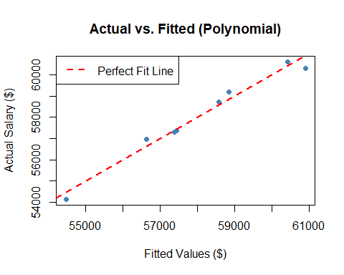
par(mfrow = c(2, 2))
plot(model_poly)
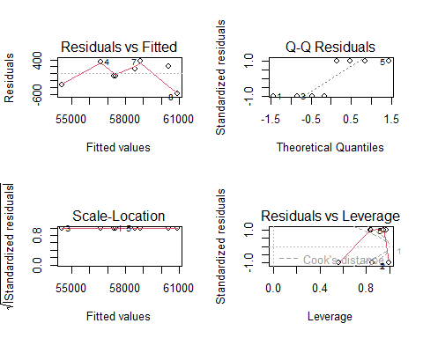
par(mfrow = c(1, 1))

4. Log Transformation Regression Model
# Experience + 1 to avoid log(0) since one observation has 0 years of experience
df$log_Employment <- log(df$Employment..in.years.)
df$log_Experience <- log(df$Experience..in.years. + 1)
df$log_Education <- log(df$Education..in.years.)
model_log <- lm(Salary ~ log_Employment + log_Experience + log_Education,
data = df)
summary(model_log)
##
## Call:
## lm(formula = Salary ~ log_Employment + log_Experience + log_Education,
## data = df)
##
## Residuals:
## 1 2 3 4 5 6 7 8
## -1384.41 468.71 -26.01 -347.57 50.93 508.26 840.88 -110.80
##
## Coefficients:
## Estimate Std. Error t value Pr(>|t|)
## (Intercept) 48264.0 9080.7 5.315 0.00603 **
## log_Employment 3377.3 676.9 4.989 0.00755 **
## log_Experience 658.4 812.2 0.811 0.46308
## log_Education 696.4 3910.5 0.178 0.86732
## ---
## Signif. codes: 0 '***' 0.001 '**' 0.01 '*' 0.05 '.' 0.1 ' ' 1
##
## Residual standard error: 899.7 on 4 degrees of freedom
## Multiple R-squared: 0.8955, Adjusted R-squared: 0.817
## F-statistic: 11.42 on 3 and 4 DF, p-value: 0.01977
cat("Log R-squared: ", round(summary(model_log)$r.squared, 4), "\n")
## Log R-squared: 0.8955
cat("Log Adjusted R-squared:", round(summary(model_log)$adj.r.squared, 4), "\n")
## Log Adjusted R-squared: 0.817
rmse_log <- sqrt(mean(residuals(model_log)^2))
cat("Log RMSE: $", round(rmse_log, 2), "\n")
## Log RMSE: $ 636.2

Interpretation
The log transformation model replaces each predictor with its natural log, capturing diminishing returns — meaning each additional year of employment, experience, or education has a progressively smaller effect on salary.
Significance of Predictors:
- log(Employment) (p = 0.00755, **): Statistically significant at α = 0.05. For every 1% increase in employment tenure, salary is estimated to increase by approximately $33.77. Employment remains the dominant predictor of salary even after log transformation.
- log(Experience + 1) (p = 0.463): Not statistically significant. Experience does not independently explain salary variation once employment and education are accounted for.
- log(Education) (p = 0.867): Not statistically significant. Education contributes very little unique explanatory power in this model.
Overall Model Significance:
The F-statistic is 11.42 on 3 and 4 degrees of freedom, with a p-value of 0.01977. The log model is statistically significant overall at α = 0.05, meaning the three log-transformed predictors together explain a significant portion of salary variation.
R², Adjusted R², and RMSE:
- R² = 0.8955: The log model explains 89.55% of salary variation.
- Adjusted R² = 0.817: After adjusting for the number of predictors, the log model retains 81.7% explanatory power — lower than the linear model (90.17%) and the polynomial model (82.85%).
- RMSE = $636.20: On average, predictions deviate from actual salaries by $636.20, which is comparable to the linear model and notably worse than the polynomial model.
df$Fitted_log <- fitted(model_log)
plot(df$Fitted_log, df$Salary,
main = "Actual vs. Fitted (Log)",
xlab = "Fitted Values ($)",
ylab = "Actual Salary ($)",
pch = 16, col = "darkorange")
abline(a = 0, b = 1, col = "red", lwd = 2, lty = 2)
legend("topleft", legend = "Perfect Fit Line", col = "red", lty = 2, lwd = 2)
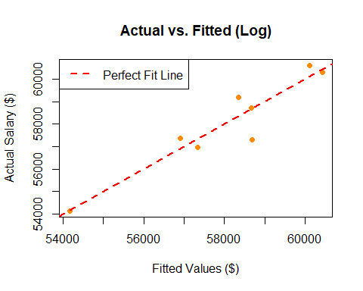
par(mfrow = c(2, 2))
plot(model_log)
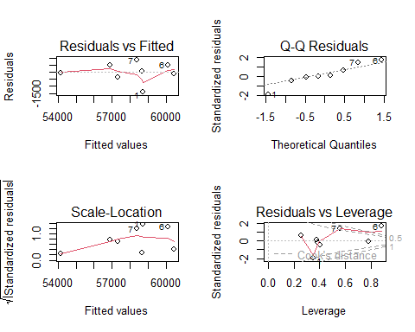
par(mfrow = c(1, 1))

5. Model Comparison
cat("Model Comparison:\n")
## Model Comparison:
cat(" R-squared Adj. R-squared RMSE\n")
## R-squared Adj. R-squared RMSE
cat("Polynomial Model: ", round(summary(model_poly)$r.squared, 4), " ",
round(summary(model_poly)$adj.r.squared, 4), " $",
round(rmse_poly, 2), "\n")
## Polynomial Model: 0.9755 0.8285 $ 308.01
cat("Log Model: ", round(summary(model_log)$r.squared, 4), " ",
round(summary(model_log)$adj.r.squared, 4), " $",
round(rmse_log, 2), "\n")
## Log Model: 0.8955 0.817 $ 636.2

Interpretation
Model | R² | Adjusted R² | RMSE
Polynomial | 0.9755 | 0.8285 | $308.01
Log | 0.8955 | 0.8170 | $636.20
The polynomial model achieves a higher R² and lower RMSE, suggesting better raw fit to the data. However, its adjusted R² is only marginally better than the log model (0.8285 vs. 0.8170), and the polynomial model is not statistically significant overall (p = 0.2888) compared to the log model (p = 0.01977). The polynomial model’s apparent accuracy is likely inflated by overfitting, with 6 parameters and only 8 observations, there is only 1 degree of freedom left for error estimation.
The log model is the more reliable choice for this dataset. It is statistically significant, maintains a reasonable adjusted R², and correctly identifies log(Employment) as the only significant predictor — consistent with all prior analyses. With a larger sample size, both models could be evaluated more conclusively.

